**Cloud computing** is a way to get **IT services** like **computing power**, **storage**, and **databases** over the internet, paying only for what you use. Instead of buying and maintaining **physical data centers** and **servers**, you can access these services from various providers. To start learning cloud computing, you can choose from popular providers such as **Amazon Web Services (AWS)**, **Microsoft Azure**, **Google Cloud Platform (GCP)**, or **Oracle Cloud**.

**What is Traditional Architecture?**

Traditional IT infrastructure comprises **physical hardware and software components**, including data centers, servers, networking hardware, and enterprise applications. Maintaining such an infrastructure involves significant costs and challenges:

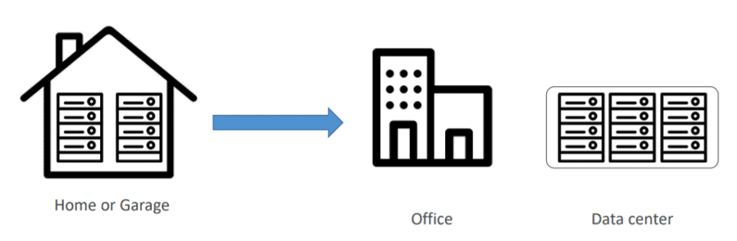

**Problems With Traditional Architecture**

* Pay the rent for the **data center**
* Pay for **power supply, cooling, and maintenance**
* **Adding and replacing hardwar**e takes time
* **Scaling** is limited
* Hire a **team to monitor the infrastructure**
* How do you deal with **disasters?** (earthquake, power shutdown, fire)

**What is Cloud Computing?**

The term ‘**cloud computing**’ refers to the technology that makes the cloud work. This includes some form of**virtualized IT infrastructure—servers**, operating system software, networking, and other infrastructure that’s abstracted using special software so that it can be pooled and divided irrespective of physical hardware boundaries. For example, a single hardware server can be divided into multiple servers.

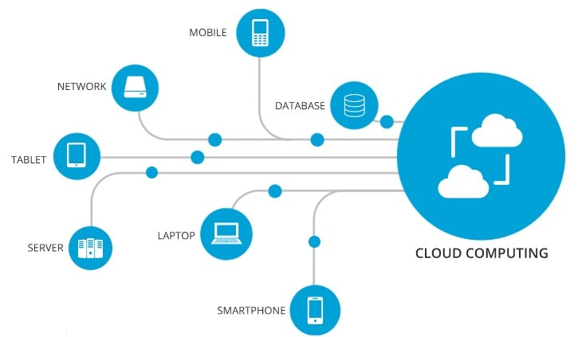

**How Does It Overcome the Problems of Traditional Architecture?**

* **Lower IT costs:**

The cloud helps you to **offload some or most of the costs and effort** of purchasing, installing, configuring, and managing your own on-premises infrastructure.

* **Improve agility and time-to-value:**

With the help of the cloud, your organization can **start using enterprise applications within a minute**, instead of waiting weeks or months for IT to respond to a request, purchase and configure supporting hardware, and install the software. It also lets you **empower certain users, specifically developers and data scientists**, to help themselves with software and support the infrastructure.

* **Scale more easily & cost-effectively:**

As the cloud provides elasticity, instead of purchasing the excess capacity that **sits vacant when it is no longer required**, you can **scale capacity up or down in response to spikes and dips in traffic**.

**Characteristics Of  Cloud Computing**

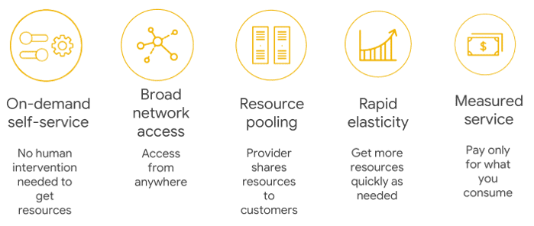

**On-Demand Self-Service:** Cloud services **do not require any human administrators or intervention**; the users themselves can **provision and manage computing resources** as needed.

**Broad Network Access:**Computing services are generally provided **over standard networks and heterogeneous devices**.

**Resource Pooling:** The IT resources (e.g., Compute, Networks, Storage, Applications, and Database services) present are **shared across multiple applications and occupants** in an uncommitted manner. **Multiple clients are provided service from the same physical resource**.

**Rapid Elasticity:** The IT resources (e.g., Compute, Networks, Storage, Applications, and Database services) present are **shared across multiple applications and occupants** in an uncommitted manner. **Multiple clients are provided service from the same physical resource**.

**Measured Service:**The **resource utilization is tracked and monitored** for each application and occupant; it will provide both the user and the resource provider with **accountability for what has been used**. This is done for various reasons, like **monitoring billing, security concerns, and effective use of resources**.

**Why Cloud?**

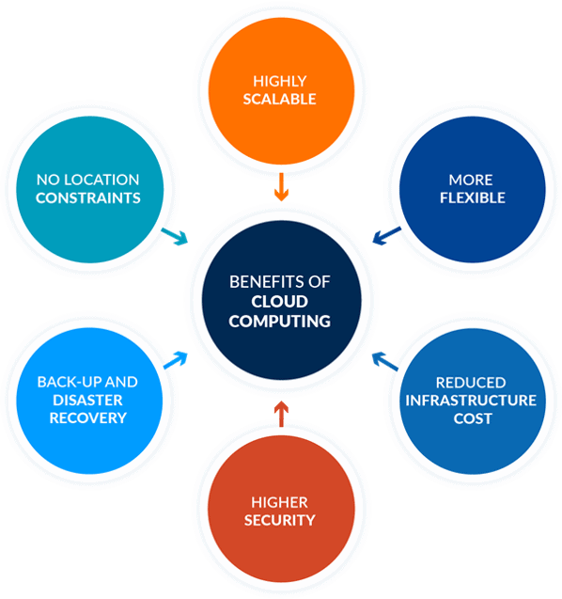

**Highly Scalable**

You can**scale up or scale down your operation and storage** needs as quickly as suits your situation, allowing flexibility as required. Rather than purchasing or provisioning the expensive upgrades yourself, your service provider can handle all this for you. Using the cloud will help you free up your time so you can get on with running your business.

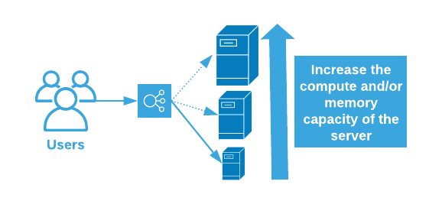

**More Flexible**

Offers businesses more flexibility overall versus hosting on a local server. And **if you need extra bandwidth, then a cloud-based service can meet your requirements instantly**, rather than undergoing a complex (and expensive) update to your IT infrastructure.

**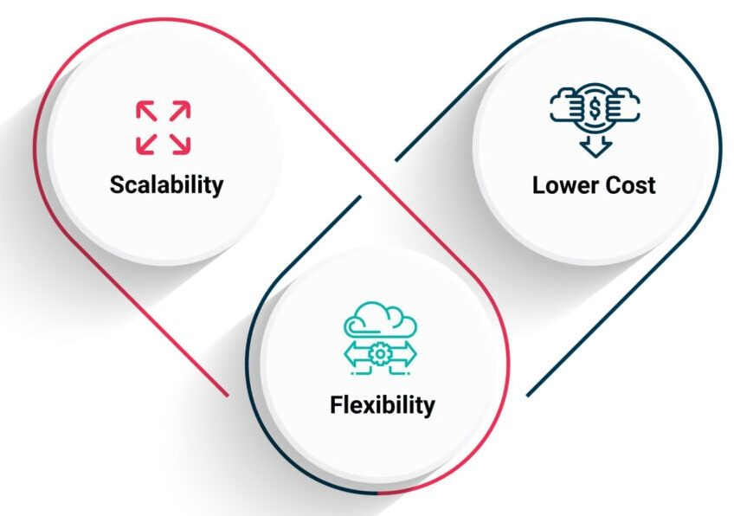  
Reduced Infrastructure Cost**

Moving to the cloud may **reduce the cost of managing and maintaining your IT systems**. Rather than purchasing expensive assets and equipment for your business, you can reduce your costs by using the resources of your cloud service provider. You may be able to reduce your operating and management costs because:

* The cost of system upgrades and new hardware and software may be included in your contract.
* There is no need to pay wages for expert staff
* Your energy consumption costs may be reduced
* There are fewer time delays.

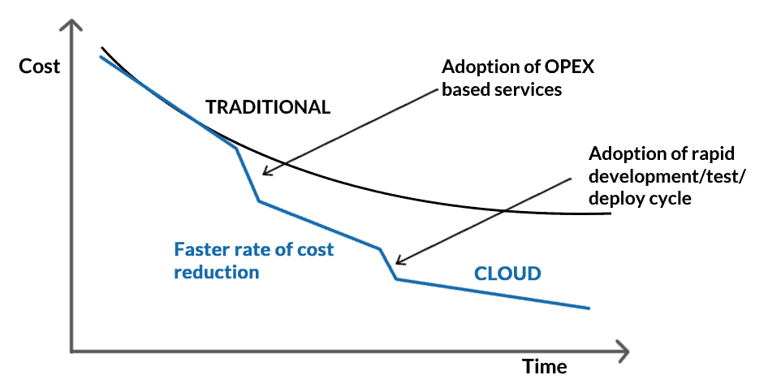

**Higher Security**

For many cloud customers, security is a priority. Users will buy more than in traditional environments, based on their reputations for their integrity, confidentiality, and resilience, as well as the safety services of their providers. This **remains a strong incentive to enhance security best practices and compete in security** for cloud providers.

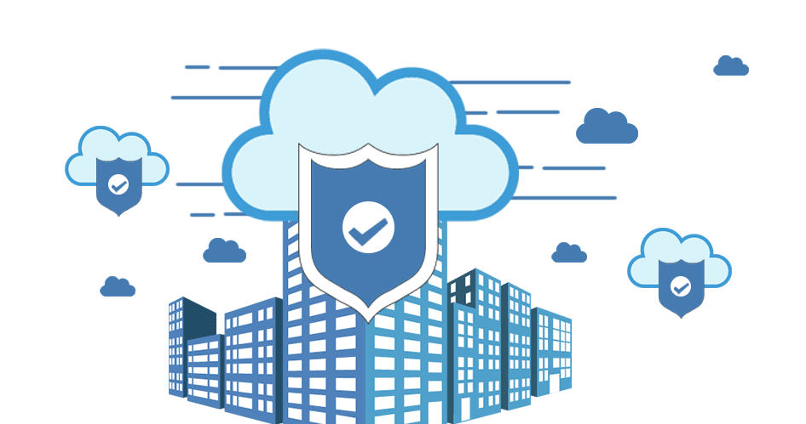

**High Availability**

The term High Availability refers to a system (a network, a server array or cluster, etc.) that is **designed to avoid loss of service by reducing or managing failures and minimizing planned downtime**. In an organization, the system is expected to be highly available when life, health, and well-being, including economic well-being, are at stake.

**Disaster Recovery**

One of the factors that contributes to the **success of a business is controlling the resources.** Unfortunately, no matter how in control your organization is, maybe when it comes to its processes, there will always be things that are completely out of your control, and the downtime in your services leads to lost productivity, revenue, and organizational reputation, so there is something you can do to help speed up your recovery. Cloud services provide quick data recovery for all kinds of emergency scenarios, from natural disasters to power outages.

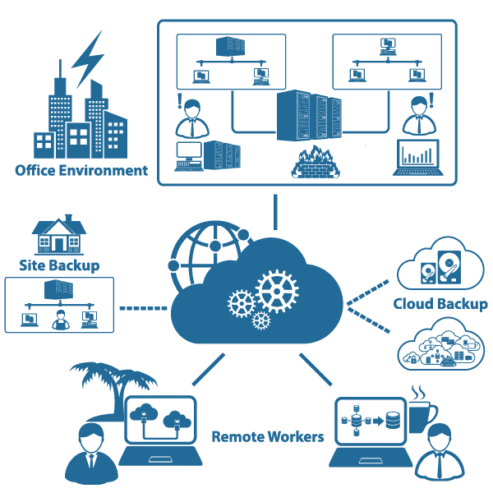

**Fault Tolerance**

**Fault tolerance** is the capacity of a system or service to carry on without interruption or performance deterioration, even if one or more instances or components malfunction. The objective is to guarantee high service availability and dependability in the event of network outages, software bugs, hardware malfunctions, or other unforeseen challenges.

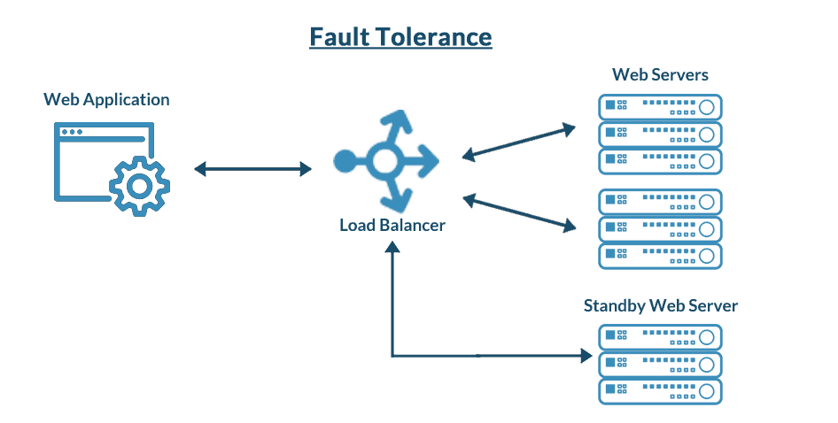

**No Location Constraints**

You can access your data from home, the office, or any other location (providing you have an internet connection). If you need access to your data while you are off-site, you can connect to your virtual office quickly and easily.

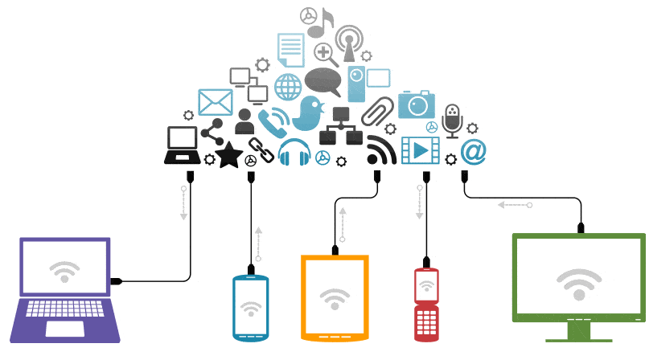

**Cloud Service Model**

There are three types of service models. Each type of cloud computing provides different levels of control, flexibility, and management, so you’ll select the proper set of services for your needs. The**three service models**are as follows:  
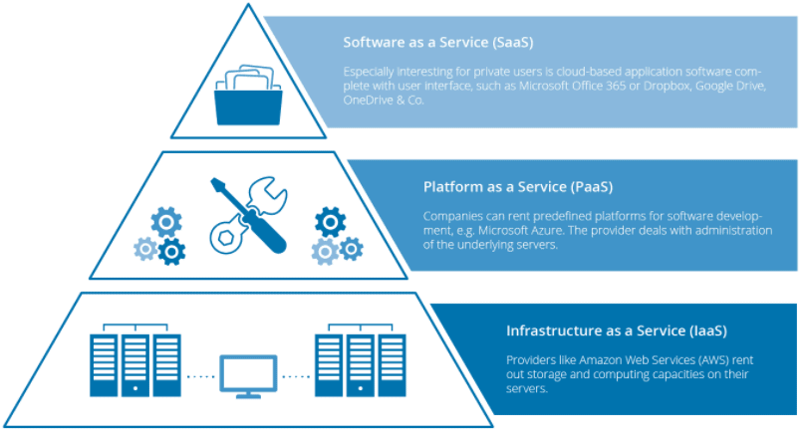

**Infrastructure As A Service (IaaS)**

* It is the**most flexible** type of service which lets you rent the hardware and contains the basic building blocks for cloud and IT.
* **It gives you complete control over the hardware** that runs the application (servers, VMs, storage, networks & operating systems).
* IaaS gives you the very best level of flexibility and management control over your IT resources.
* **Examples** of IaaS: VM or EC2 (from AWS), storage, or networking.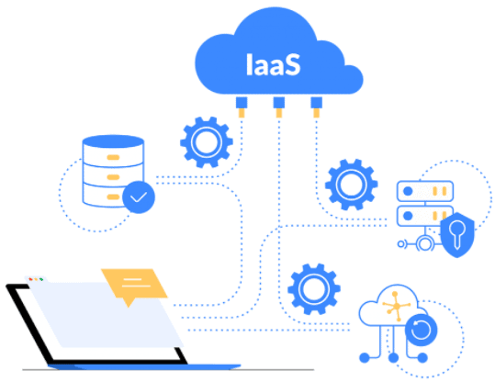

**Platform As A Service (PaaS)**

* PaaS is a**service model** that provides a **ready-to-use development environment** where developers can specialize in writing and executing high-quality code to make customized applications.
* PaaS will help you **create an application quickly without managing the underlying infrastructure**. For example, when deploying a web application using PaaS, you **don’t have to install the OS, web server, or even system patching**. However, you can **scale the resources and add new features** to your services.
* **Examples of PaaS**: **Elastic Beanstalk or Lambda from AWS**, **WebApps, Functions or Azure SQL DB from Azure**, **Cloud SQL DB from Google Cloud**, or **Oracle Database Cloud Service from Oracle Cloud**.  
  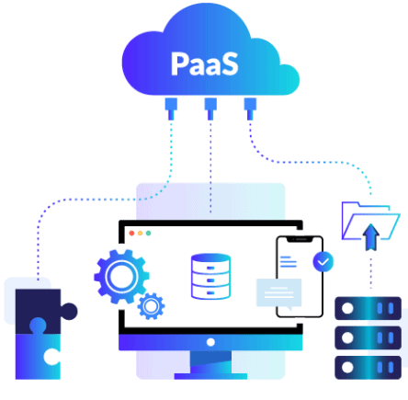

**Software As A Service (SaaS)**

* SaaS provides you with a **complete product** that is **run and fully managed** by the **service provider**.
* The **software is hosted online** and made available to **customers** on a **subscription basis or for purchase** in this **cloud service model**.
* With a SaaS offering, you **don’t need to worry about** how the **service is maintained** or how the **underlying infrastructure** is **maintained**. It would help if you **believed in how you’d use that specific software**.”
* Examples of SaaS: **Microsoft Office 365**, **Oracle ERP/HCM Cloud**, **SalesForce**, **Gmail**, or **Dropbox**.  
  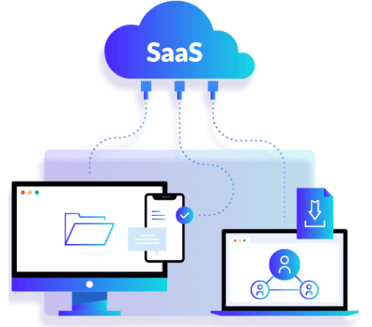

**Graphical Comparison of Cloud Computing Service Models**

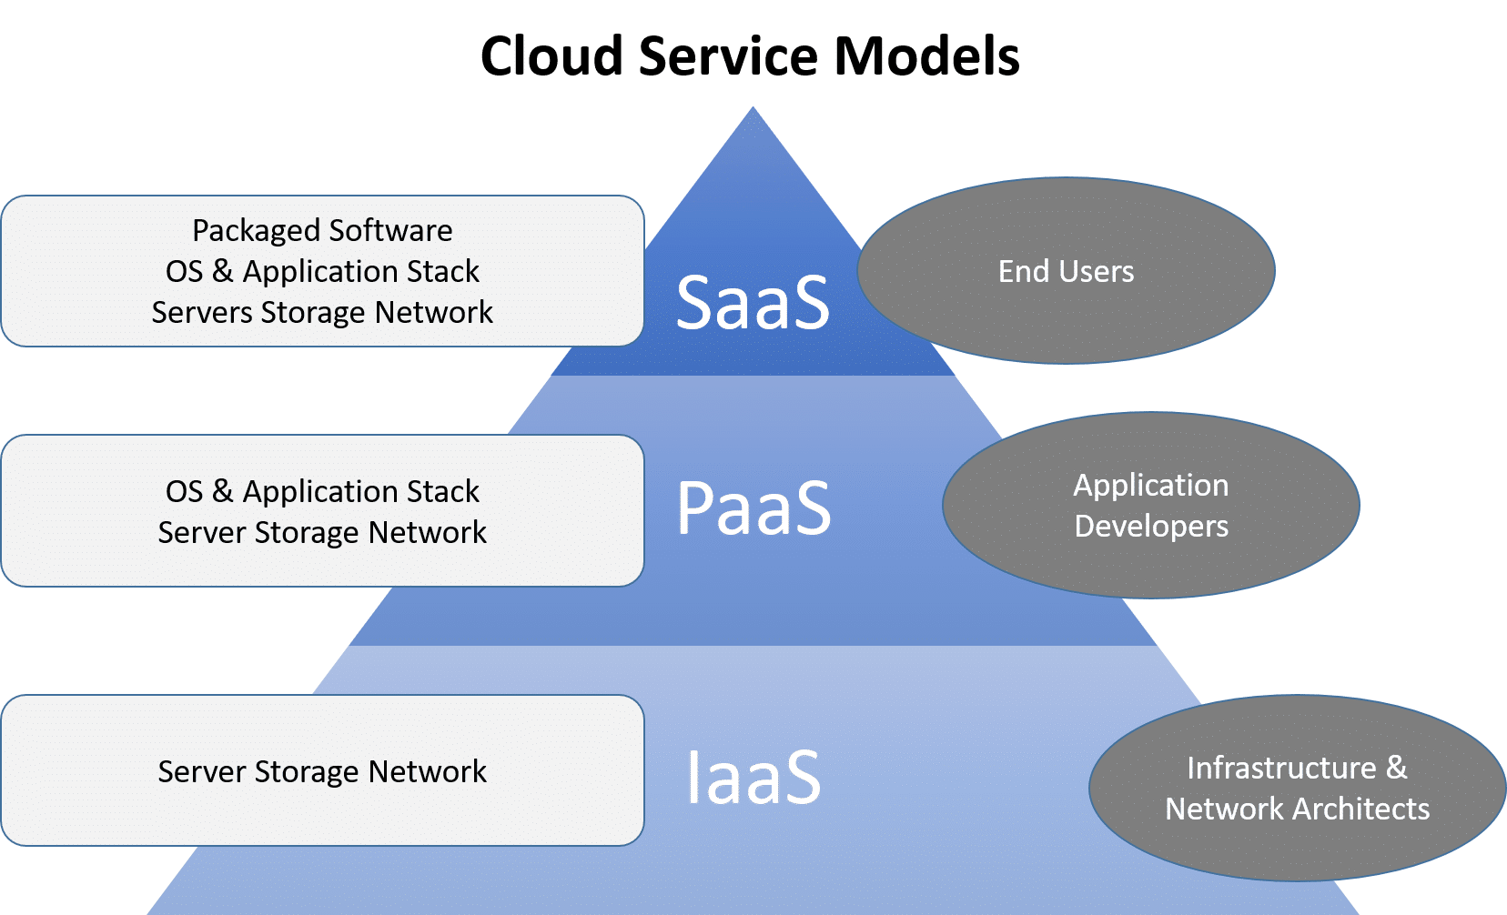

**Which Cloud Service Model To Learn?**

One of the most common questions we get from our students is: **Which Cloud Computing Service Model I should learn?**

* So, if you are a System Administrator, you should learn both **Infrastructures as a Service (IaaS) and Platform as a Service (PaaS).** The reason is that whatever you are developing or deploying over Infrastructure as a Service, i.e., PaaS always runs on top of IaaS. That’s the reason you should know both IaaS and SaaS.
* If you are working as a consultant, like a financial consultant, or working on a packaged application such as SAP, HRMS, etc., then you should learn **Software as a Service (SaaS).**

**Cloud Deployment Model**

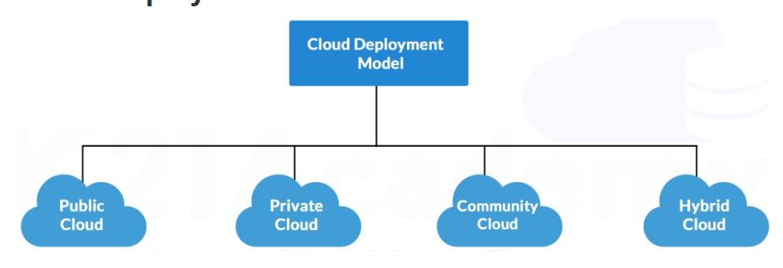

There are four primary**deployment models**: **Public**, **Private**, **Community**, and **Hybrid Cloud**. Each model offers different advantages and addresses the specific needs of organizations based on their requirements for **scalability**, **privacy**, **cost**, and **control**.

**Public Cloud**

This is accessible to the general public, offering services over the internet on a **pay-per-use** basis. These services are managed by third-party providers, which handle the **infrastructure**, **maintenance**, and **security**.

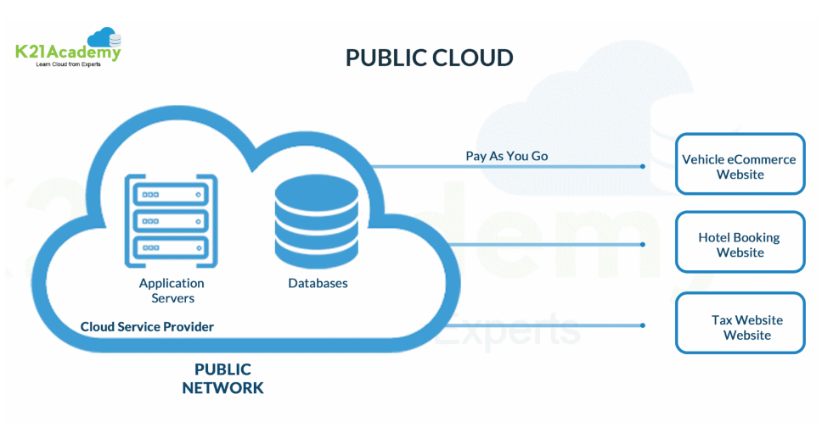

**Advantages:**

* **Scalability**: Easily scale resources up or down based on demand.
* **Cost-effective**: Pay only for what you use without the need for upfront capital expenditure.
* **High Availability**: Providers typically ensure high uptime and reliability

**Limitations:**

* **Security Concerns**: Shared infrastructure can pose security and privacy risks.
* **Less Customization**: Limited control over infrastructure and services.
* **Potential Outages**: Dependence on the provider’s reliability can lead to service disruptions.

**Examples:** [Amazon web services (AWS)](https://aws.amazon.com/free/), [Microsoft Azure](https://azure.microsoft.com/en-in/free/), and [Google Cloud Platform (GCP)](https://console.cloud.google.com/freetrial).

**Private Cloud**

This is dedicated to a single organization, offering greater control over data, security, and compliance. It can be hosted **on-premises** or by a third-party provider.

**Advantages:**

* **Enhanced Security**: Resources are not shared with others, providing better data privacy.
* 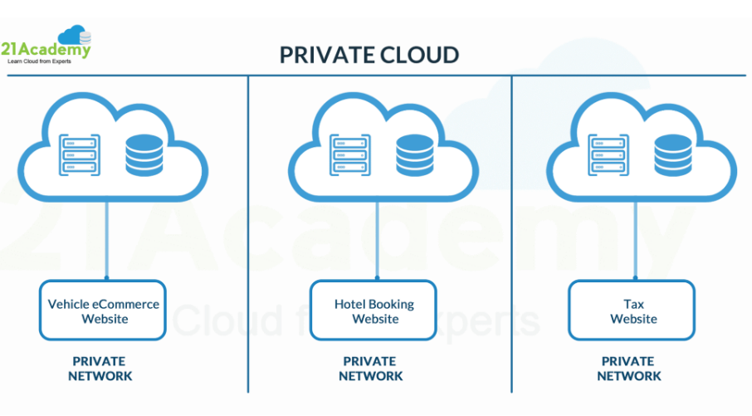
* **Compliance**: Easier to comply with industry regulations and standards.

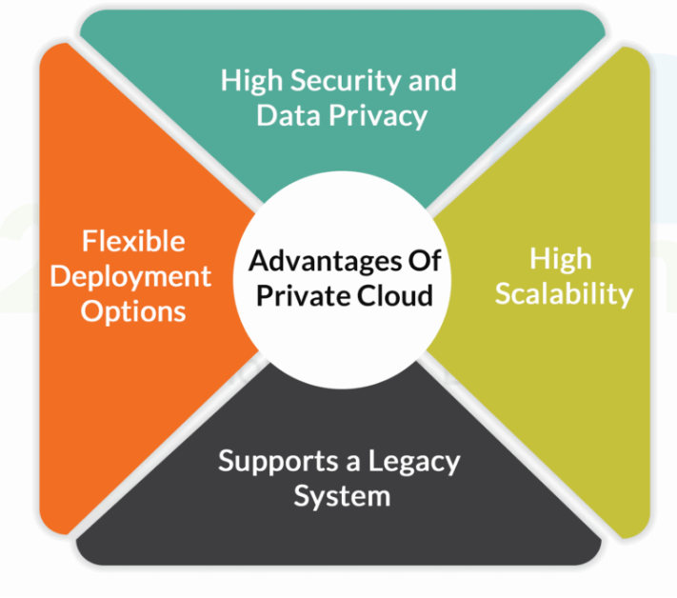

**Limitations:**

* **Cost**: More expensive due to the need for dedicated hardware and maintenance.
* **Maintenance**: Requires significant IT resources for setup and management.
* **Fixed Scalability**: Limited by the physical resources available.

**Examples:** HP Data Centers, Microsoft, Ubuntu, and Elastra-private cloud, etc.

**Community Cloud**

This serves a group of organizations with shared concerns (e.g., security, compliance, jurisdiction). It combines some benefits of both private and public clouds.

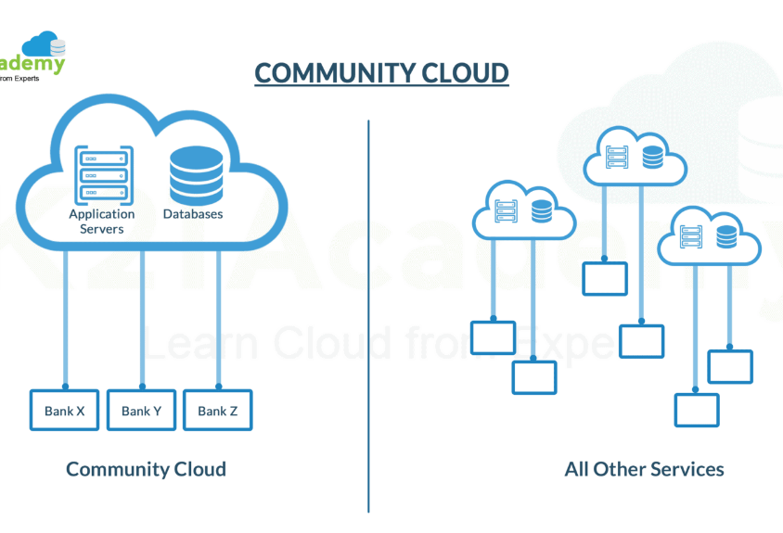

**Advantages:**

* **Cost-sharing**: Infrastructure costs are shared among the organizations, reducing individual expenses.
* **Enhanced Collaboration**: Facilitates collaboration between organizations with similar needs.
* **Security and Privacy**: Better than public cloud due to limited access to the participating organizations.

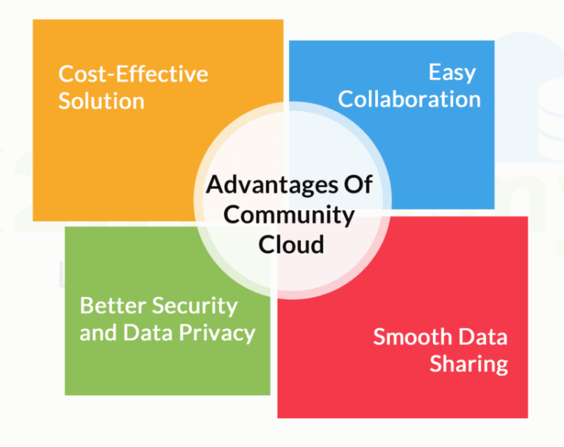

**Limitations:**

* **Limited Usage**: Not as widely adopted or supported as public and private clouds.
* **Higher Costs**: More expensive than public clouds due to specialized requirements.
* **Complex Management**: Requires coordination among multiple organizations.

**Hybrid Cloud**

This integrates public and private clouds, allowing data and applications to be shared between them. This model offers flexibility and balance between the two environments.

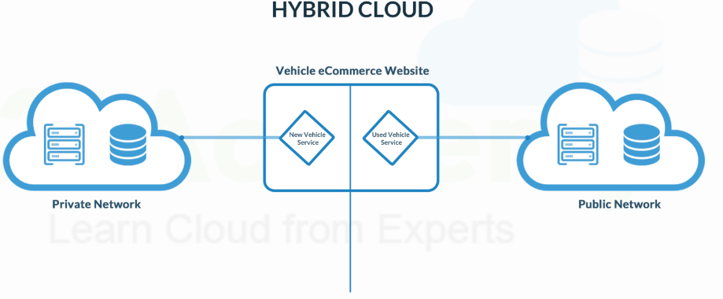

**Advantages:**

* **Flexibility**: A mix of public and private clouds allows for optimized workload placement.
* **Cost Efficiency**: Critical workloads can run on the private cloud while less-sensitive tasks utilize the public cloud.
* **Scalability**: Easily scale workloads across cloud environments based on demand.

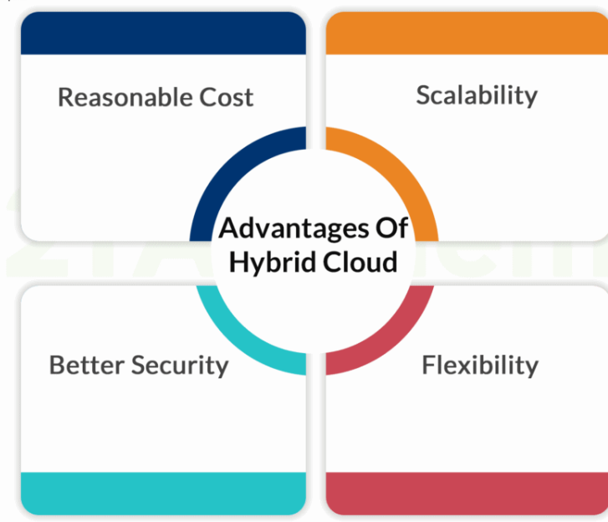

**Limitations:**

* **Complex Integration**: Requires careful management and integration between different cloud environments.
* **Security**: Potential security challenges due to data transfer between public and private clouds.
* **Management Overhead**: Requires robust management tools and practices to handle hybrid environments.

**Examples:** Oracle Cloud at Customer, Google Cloud Anthos, AWS Outpost, Microsft Azure Stack.

The primary benefit of this **hybrid cloud** is the functionality of services available to clients, such as multiple types of **deployment models**. The **Hybrid Cloud Model** is growing in demand and popularity as more businesses have adopted **cloud solutions** as a primary part of their **business model** with technology

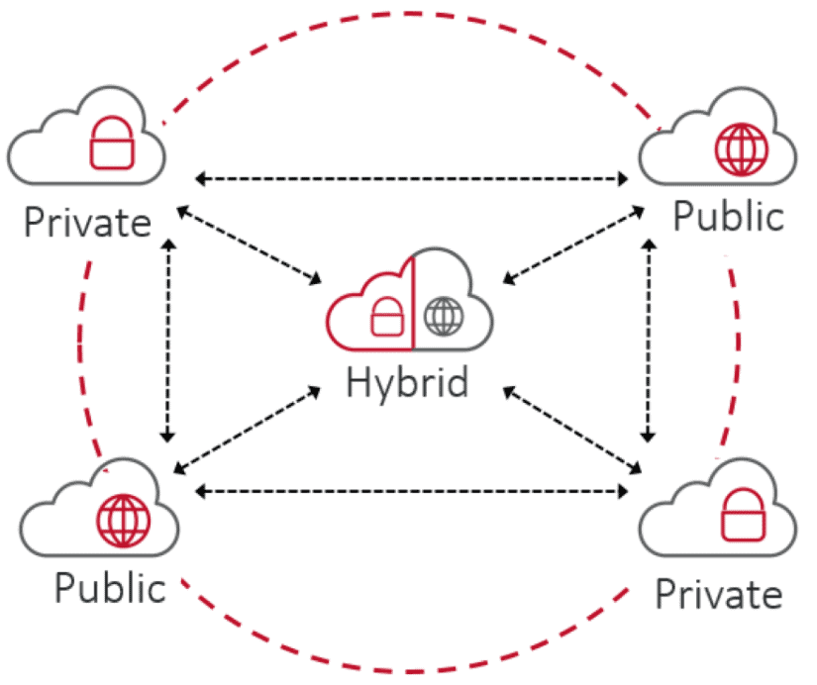

**How To Choose Between Them?**

Selecting the right **deployment model** depends on several factors:

* **Scalability**: If rapid scalability is required, consider public or hybrid clouds.
* **Security and Privacy**: For highly sensitive data, private or community clouds are preferable.
* **Cost**: Public clouds are generally more cost-effective for non-sensitive data and dynamic workloads.
* **Compliance**: Industries with strict regulatory requirements might lean towards private or community clouds.
* **Flexibility**: Hybrid clouds offer a balance, allowing organizations to utilize both private and public cloud advantages.

By understanding these **deployment models**, organizations can better align their IT strategies with their business goals, ensuring optimal **performance**, **security**, and **cost efficiency**.